MongoDB - write the corresponding MongoDB queries

1 Find all the information about each products

db.products.find({ })
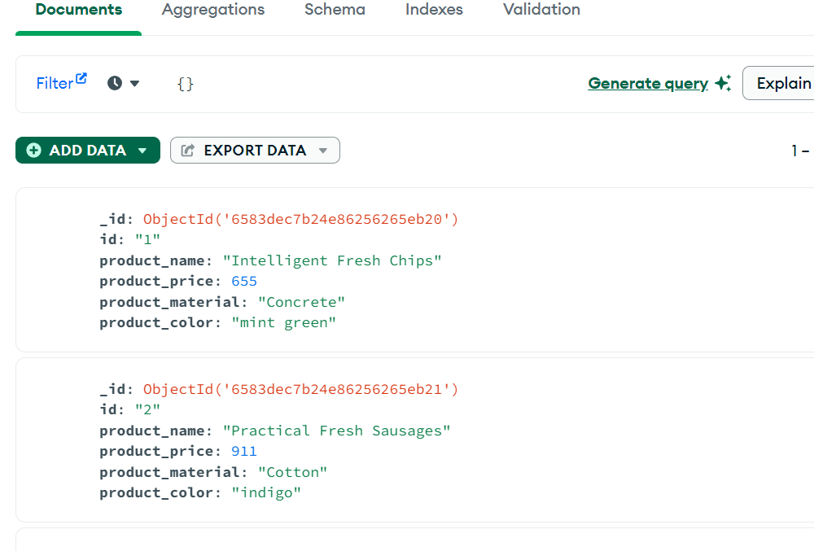

2 Find the product price which are between 400 to 800
db.products.find ( {"product_price": {"$gt":400,"$lt":800})
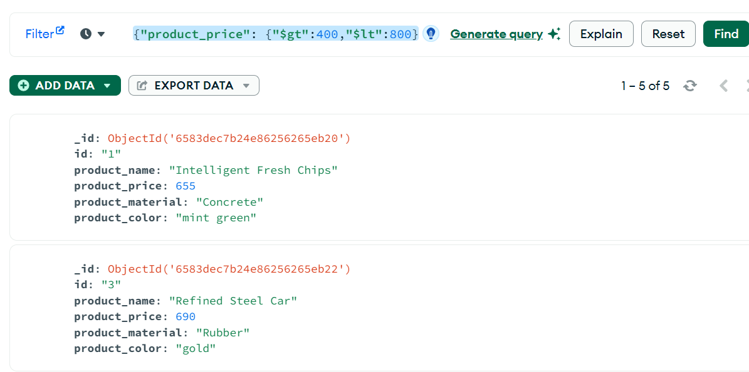

Find the product price which are not between 400 to 600

db.products.find({"product_price":{ "$not": { "$gt": 400,
"$lt": 600 }}} )
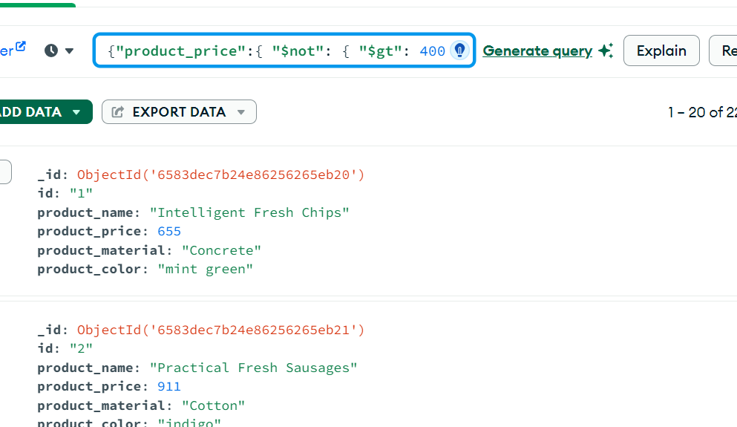

4 List the four product which are grater than 500 in price

db.products.find({"product_price":{"$gt":500}} )
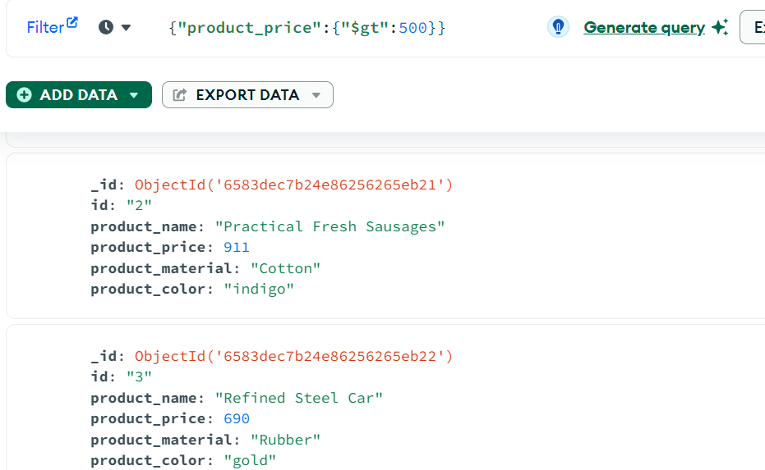

5 Find the product name and product material of each products

db.products.find({},{"product_name":1, "product_material":1} )

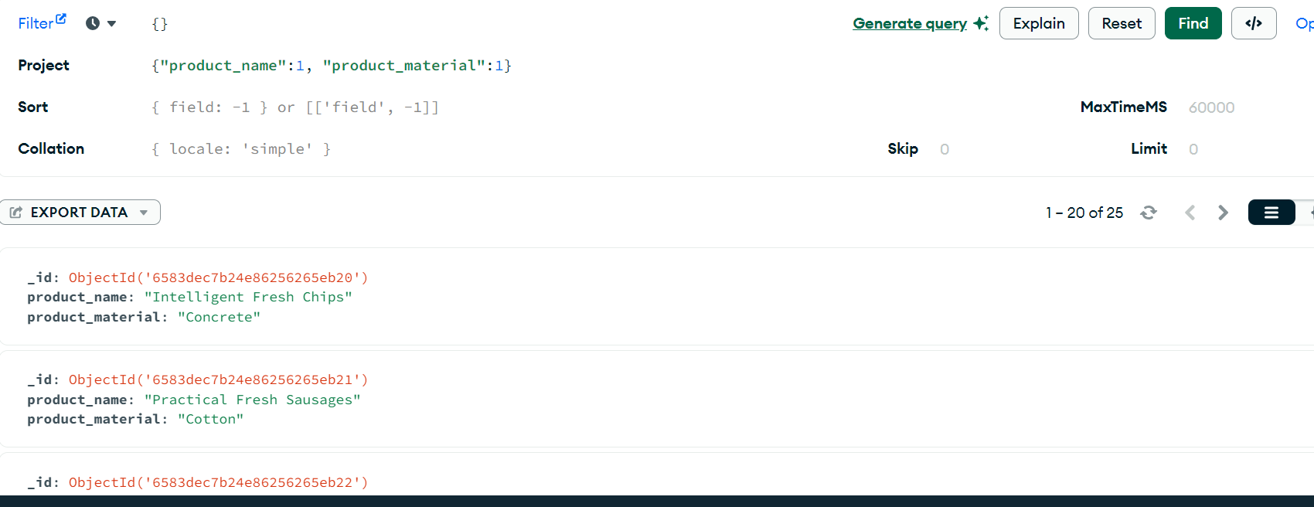

6 Find the product with a row id of 10
db.products.find({"id":{"$in":["10"]}} )

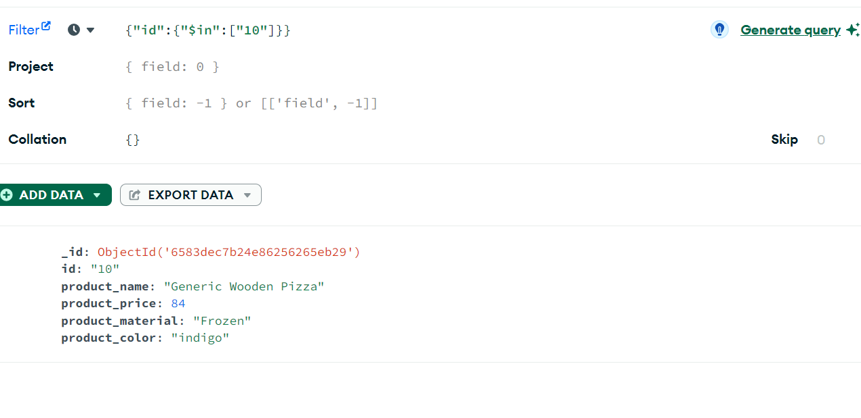

7 Find only the product name and product material

db.products.find({},{"product_name":1, "product_material":1,” _id”:0} )
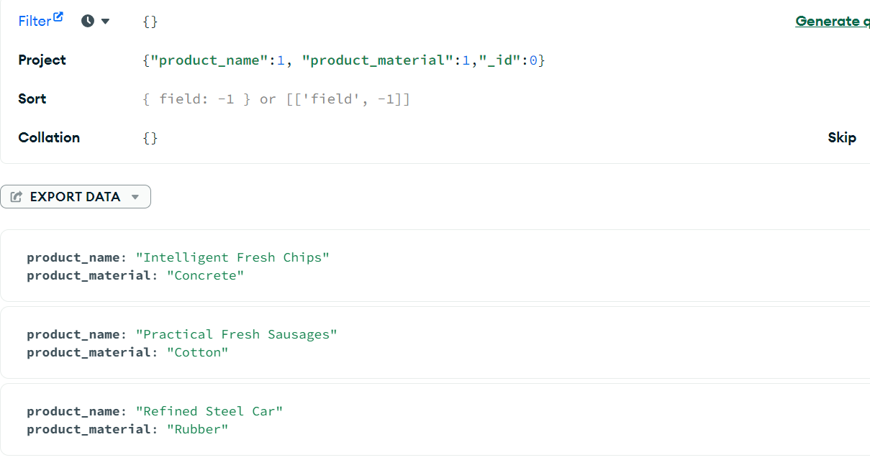

8 Find all products which contain the value of soft in product material

db.products.find({"product_material":"Soft"})

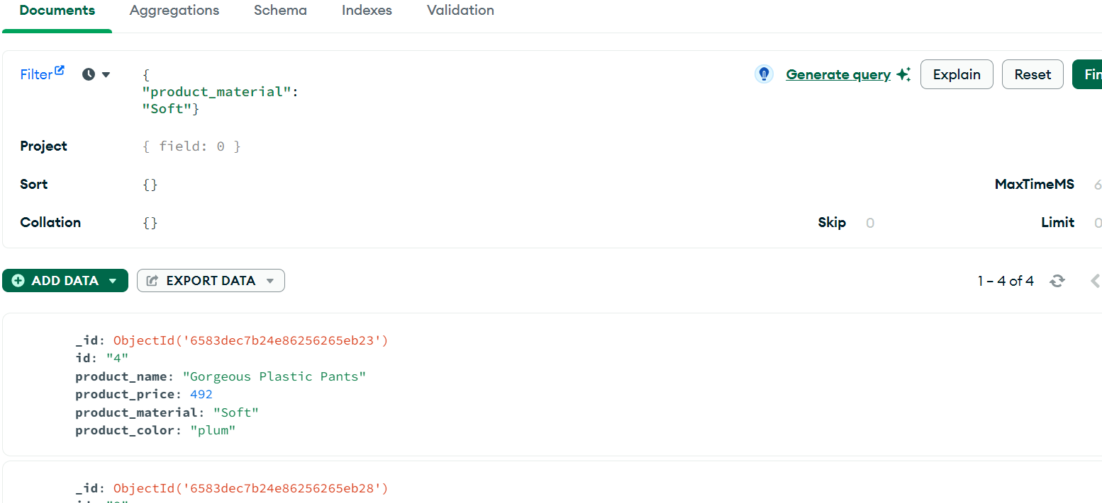

Find products which contain product color indigo and product price 492.00

db.products.find({"$and":[{"product_color": "indigo"},{"price":492.00}]} )

